Eventify - Exploratory Test Defect Report
Step 1. Explain your system context.
Prompt given to ChatGPT (Simulated for Eventify):
Eventify is an event and ticketing management system built to connect Event Organisers (like universities, concert hosts, NGOs, businesses, and festivals) with Attendees (Registered and Guest users). The core value propositions include easy event creation and management for organisers, real-time ticket sales insights, convenience for attendees to browse and purchase tickets, and instant digital ticket delivery."
Response (Contextualised System Overview):
Eventify is a comprehensive event and ticketing management system. It serves as a digital marketplace where organisers create, promote, and manage ticket sales, and attendees discover and purchase tickets securely.
Key features include:
- Account Management (Module 1): Handles user registration, login, password recovery, and profile management to ensure secure and personalised access.
- Event Creation & Management (Module 4): Allows event organisers to create, edit, manage capacity, and track event performance, ensuring efficient event operations.
- Organisers include universities, NGOs, concert hosts, businesses, and festivals.
- Ticketing & Payments (Module 3): Supports ticket purchase, QR ticket generation, refund, and cancellation through secure and transparent payment systems.
- Notifications & Communication (Module 5): Sends real-time updates, reminders, and confirmations through SMS, email, and push notifications to keep users informed.
Step 2. Explain the feature under test: Attendee Ticket Purchase & Order Management.
Prompt given to ChatGPT (Simulated for Eventify):
"As a Registered Attendee, I want to browse and discover events (search, filters by date/location/category), view seating and pricing, securely purchase tickets online (using cards, wallets, PayPal, UPI), and instantly receive my digital tickets and QR codes so that I can manage my orders and check in smoothly on the event day."
User Story Breakdown:
| ID | Title |
| :--- | :--- |
| 03.01 | Secure Ticket Purchase & Digital Delivery |
| 03.02 | Order Management (View History, Cancel/Refund) |
Step 3. Can you suggest test ideas for testing “Attendee Ticket Purchase & Order Management”?
Text from ChatGPT (Simulated Test Ideas for Modules 3 & 1):
Test Idea Category | Test Ideas
Basic Purchase Flow | ✅ Verify a Registered User can complete a purchase with a valid card, receive an instant confirmation email, and access the digital QR code ticket.
Guest/Registered User Access | ✅ Verify a Guest User can browse and view events, but is prompted to register/login before the final payment step.
Payment & Financial Validation | ✅ Test purchase using different payment methods (e.g., PayPal, UPI, Credit Card) to ensure all integrate securely and correctly mark the order status.
Promo/Discount Application | ✅ Apply a valid promo code to verify the discount is calculated correctly, and apply an invalid/expired code to verify it is rejected.
Order Cancellation & Refund | ✅ Test canceling a ticket within the set refund rules to ensure the ticket is invalidated and the refund process is initiated.
Security & Access Control | ✅ Verify that a user cannot access or manage another user's order history or digital ticket via API manipulation or URL changes.
Post-Transaction Status | ✅ After a successful purchase, check the order history to ensure the ticket status is 'Confirmed' and the event is added to the user's calendar/share options are available.
Bugs of Testing Session (Simulated Defects)
Based on a simulated exploratory test session covering Attendee Flows and System Integrations (Notifications, Payments, Security).
ID | Summary | Module/Feature | Severity | Status
SCRUM-44 | Ticket remains 'Reserved' after abandoned payment. | Ticketing & Payments (3) | High | To Do
SCRUM-45 | Cancellation confirmation email is not sent to Guest Users. | Notifications & Comm. (5) | High | To Do
SCRUM-46 | Check-in staff can access sensitive attendee demographics. | Organizer Management (4) - Access Control | Critical | To Do

Bug Detail: SCRUM-46
Assigned Check-in staff can access the Organiser's Sales Dashboard data.
Module: Organiser Management (Access Control)
Steps to Reproduce:
- Organiser (High-privilege user) creates an event.
- The Organiser assigns a Staff Member (Account B) the 'Check-in' role (Requirement 15).
- Staff Member (Account B) logs in.
- Account B navigates to the event's Sales Dashboard.
- Actual Result: Account B can view sensitive data like Total Revenue, Real-Time Ticket Sales, and Attendee Demographics (Requirement 6).
Expected Result:
The 'Check-in' role should only have access to the QR-code check-in support interface and the attendee lists. The sensitive financial reports and attendee demographics must be restricted to enforce the access control requirement and maintain compliance with data privacy (Requirement 14).
Actual Result:
The low-privilege staff member has unauthorised access to sensitive financial and marketing data.
Impact:
Critical - This is a severe security vulnerability that violates the Compliance & security requirement (PCI, GDPR/CCPA, data privacy) and the principle of least privilege, eroding the Organiser's trust.
Environment:
- Browser: Edge
- OS: macOS
Severity: Critical - Security and compliance failure.

Bug Detail: SCRUM-44
Ticket remains 'Reserved' after abandoned payment.
Module: Ticketing & Payments (3)
Steps to Reproduce:
- Navigate to an event with low ticket inventory (e.g., 5 tickets remaining).
- As a Registered Attendee, click "Purchase Ticket" and proceed to the external payment gateway (e.g., PayPal/Stripe).
- Crucial Step: Close the browser tab or hit the back button without completing the payment.
- Observe: The ticket remains unavailable in the inventory (stuck at 4 tickets remaining) for other users, even after 15 minutes (exceeding the expected timeout).
Expected Result:
The system should initiate a timeout mechanism (e.g., 5-10 minutes) for abandoned payments and automatically revert the ticket quantity back to the available inventory (5 tickets).
Actual Result:
The ticket is locked as 'Reserved' indefinitely, resulting in lost sales for the organiser.
Impact:
High - Directly impacts the Organiser's revenue stream (Commission on Ticket Sales) as sellable tickets are artificially locked out.
Environment:
- Browser: Chrome
- OS: Windows
Severity: High - Blocks core business functionality (selling tickets).

Bug Detail: SCRUM-45
Cancellation confirmation email is not sent to Guest Users.
Module: Notifications & Communication (5)
Steps to Reproduce:
- As a Guest User, browse events and purchase a ticket (Guest User can purchase tickets, but notifications are Limited via email).
- Receive the initial order confirmation email (Successful).
- Use the link provided in the confirmation email to Cancel/Refund tickets (Requirement 11) within the allowed rules.
- The system confirms the cancellation on screen.
- Observe: The cancellation/refund confirmation email is never received by the Guest User.
Expected Result:
A Guest User, who only receives notifications via email (Requirement 8 - Limited), must receive a crucial cancellation/refund confirmation email.
Actual Result:
The cancellation confirmation is only attempted via an in-app notification (which the Guest User cannot access), and the corresponding mandatory email is skipped.
Impact:
High - Causes uncertainty for the Guest User about the status of their order and refund, resulting in high load on the Customer Support Team (Internal Stakeholder).
Environment:
- Browser: Chrome
- OS: Windows
Severity: High - Impacts customer trust and increases operational cost (Customer Support).

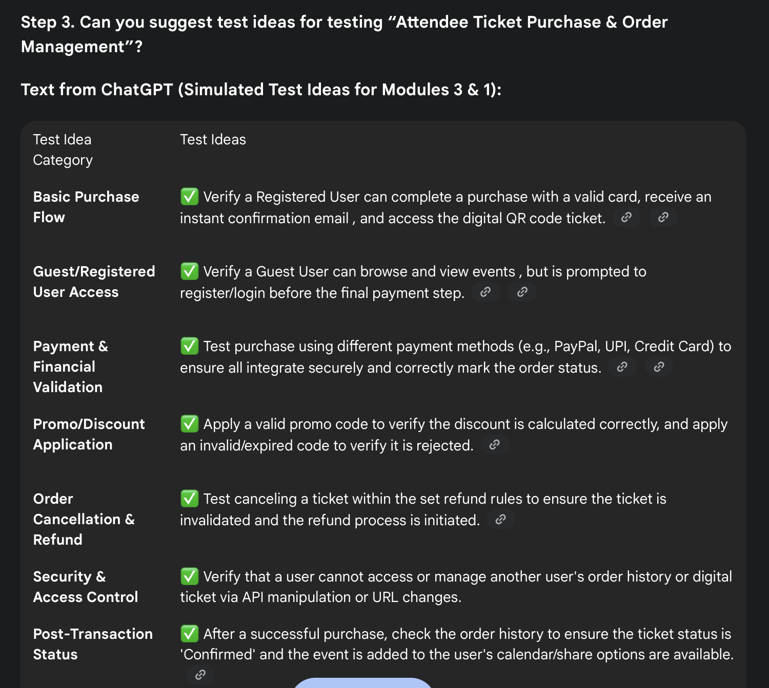

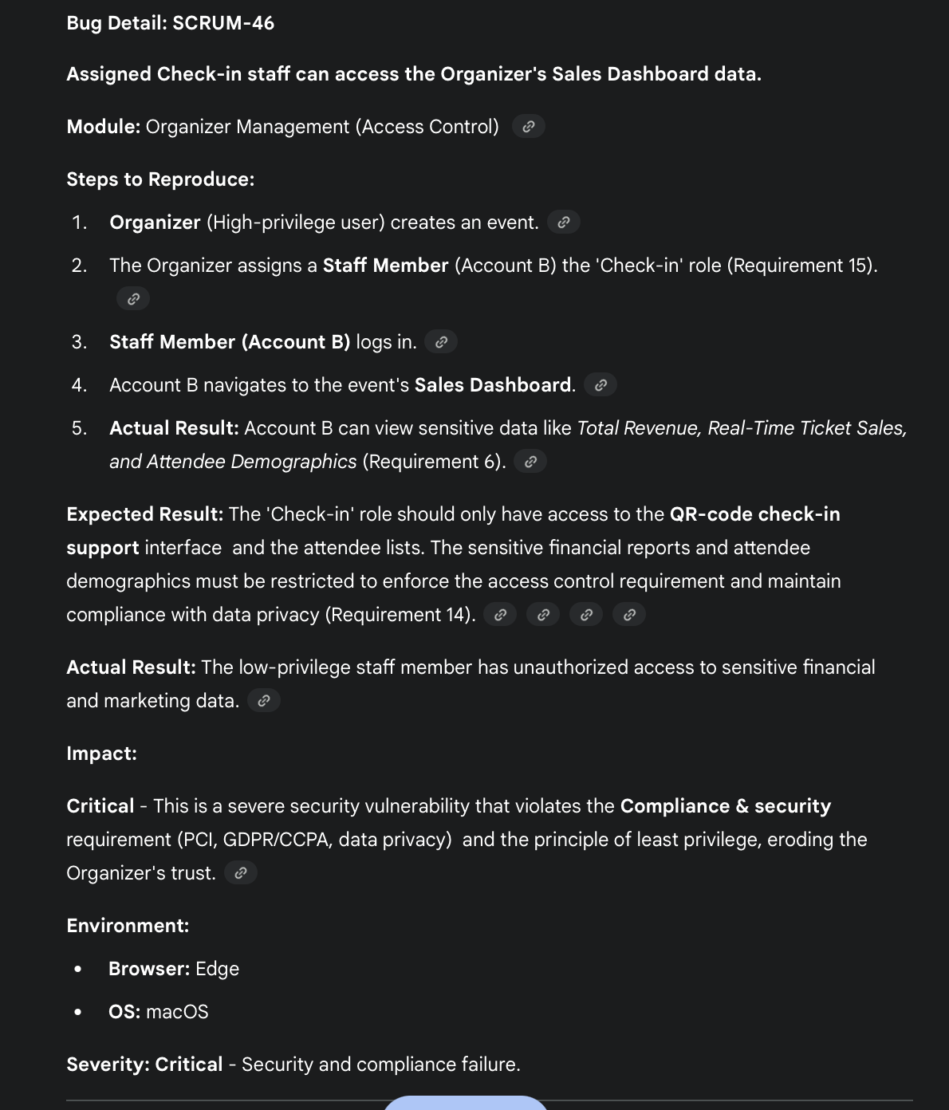

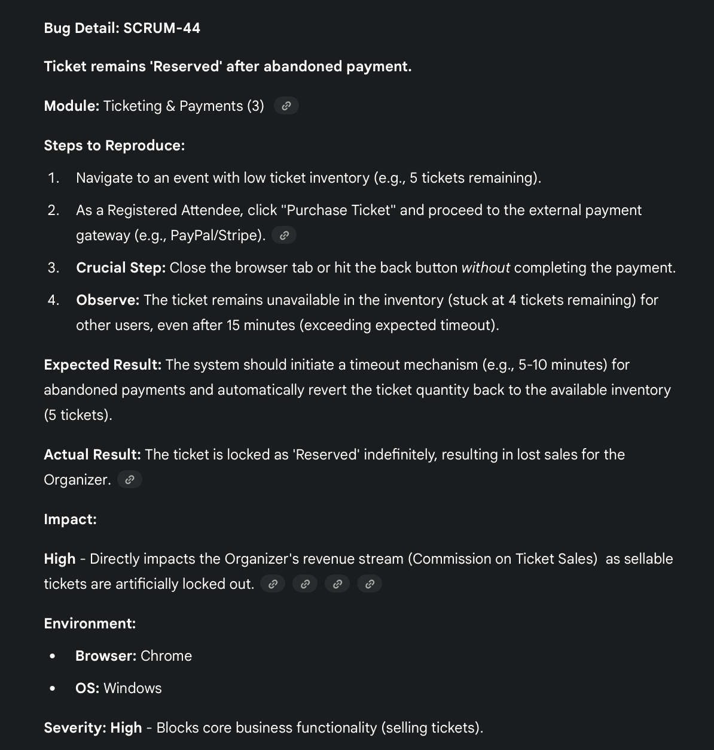

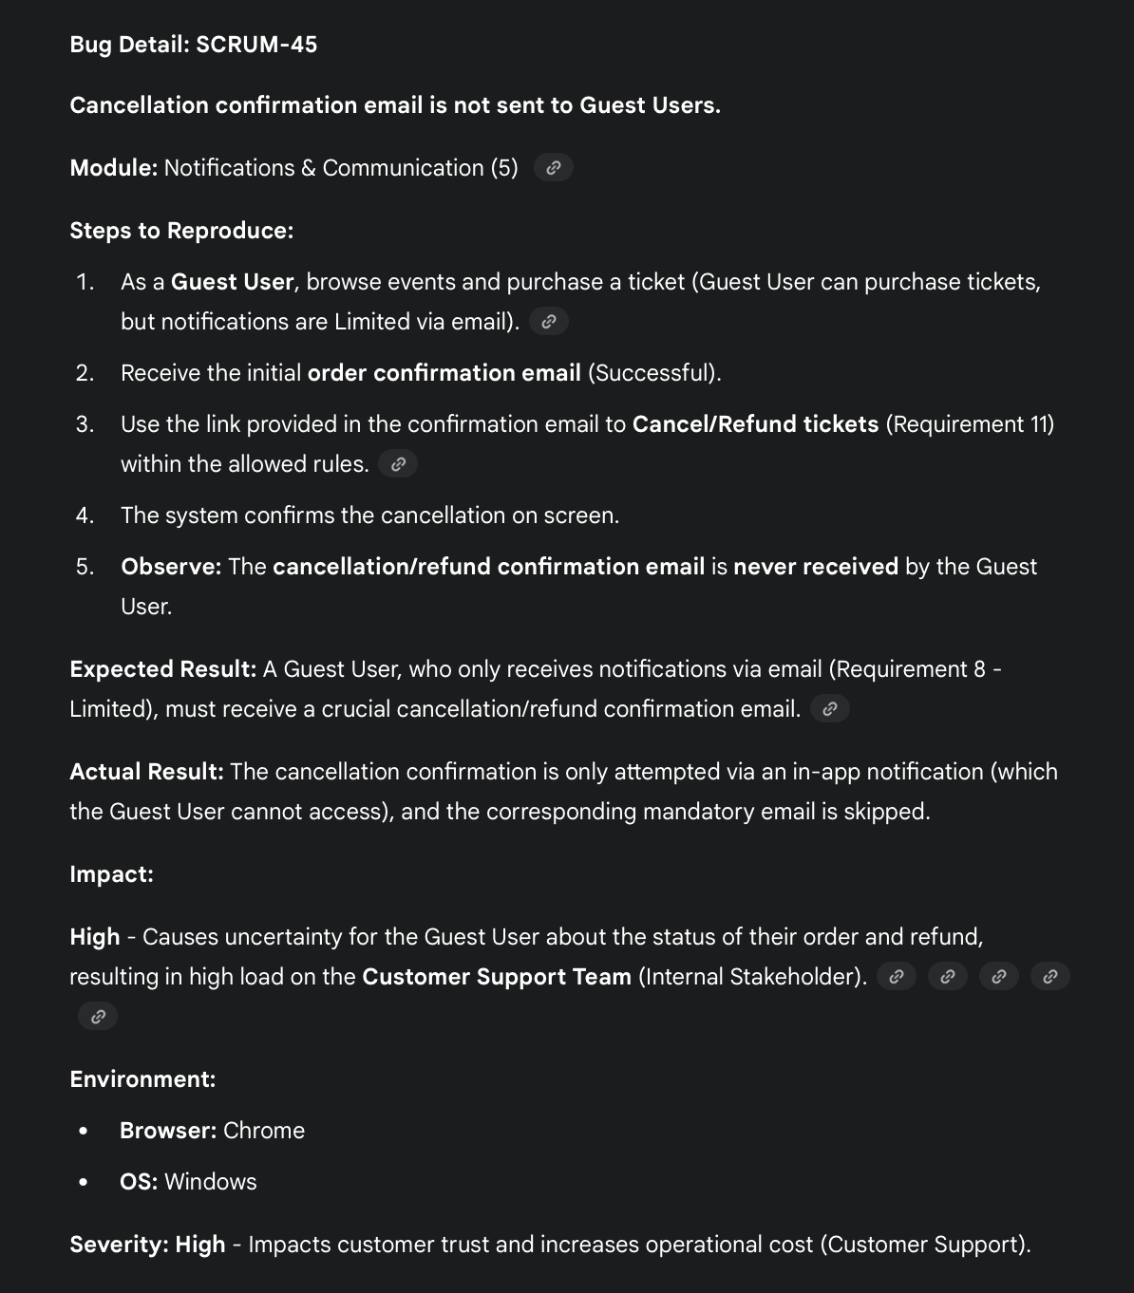

The few bugs I created :

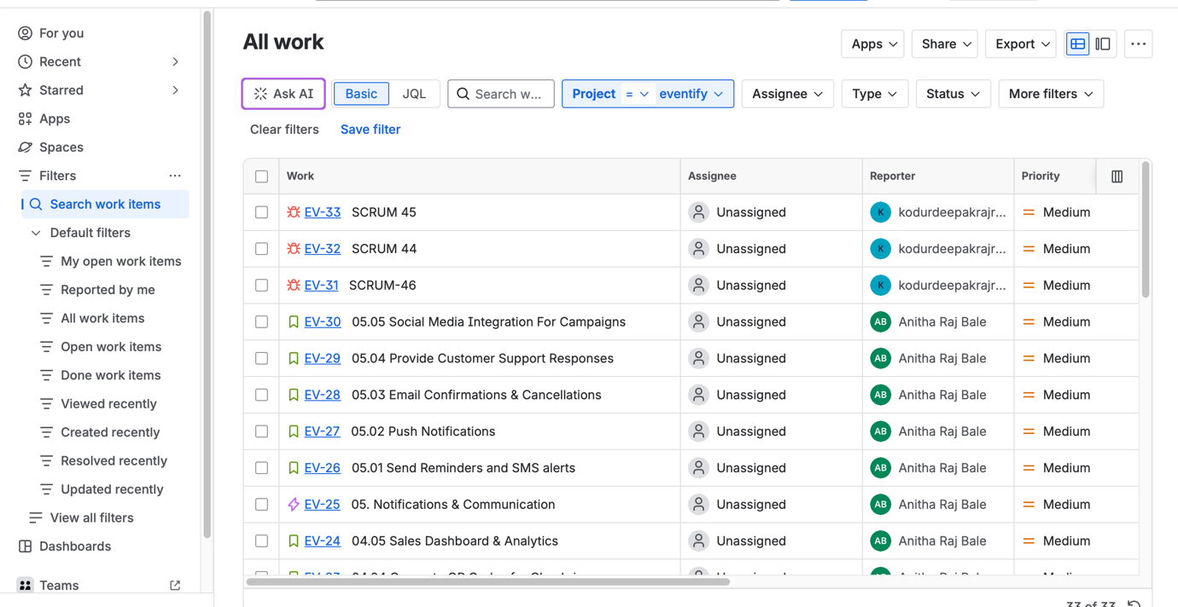

Bug details
SCRUM 45:
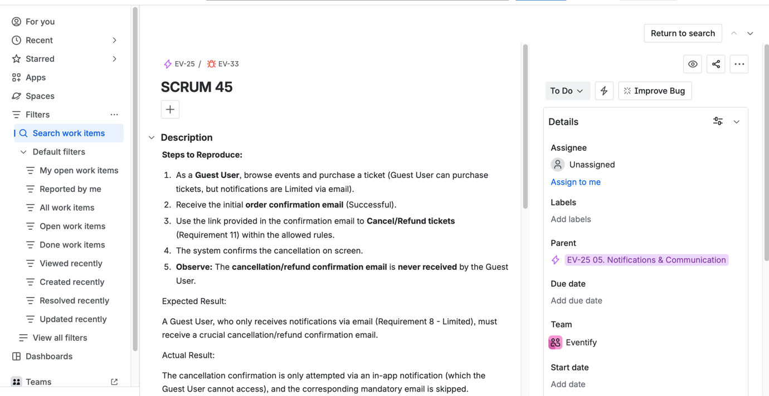

SCRUM 44:
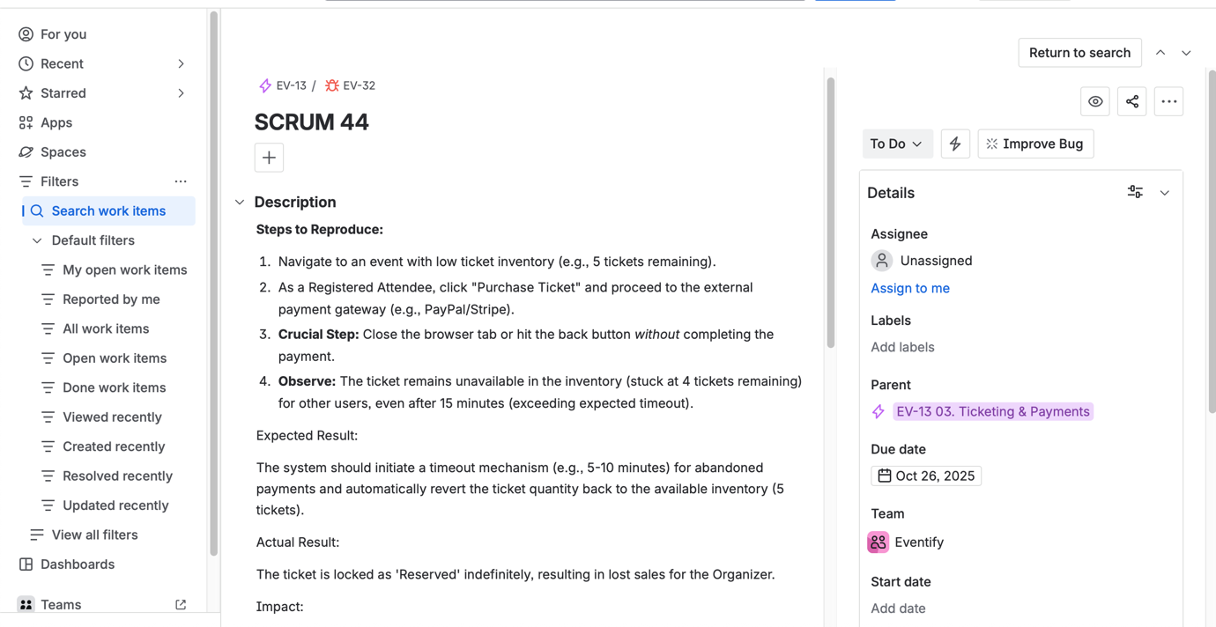

SCRUM 46:

